CORDS Operational Research Projects
Presentation for CORDS Website

- Establishment of a Mobile Phone Surveillance System to improve detection and response to communicate health threats – SACIDS, EAIDSNet and MBDS

Petra’s comments :

- Will the RC information be connected to the member area of the CORDS
website?

Project Executive Summary:

The East and Southern African countries mostly rely on paper-based systems for surveillance of infectious diseases which does not allow rapid and reliable transfer of data and therefore hinder effective surveillance and response. Following the successful implementation of a project piloting the use of mobile technologies for disease surveillance, SACIDS and EAIDSNet are now proposing to establish at national level in 6 border countries a mobile phone system to improve disease detection and response.

Project Background :

In Eastern and Southern Africa, the burden of infectious disease represents an ongoing public health challenge ; outbreaks of disease continue to occur and endemic pathogens persist. Public health disease surveillance in Eastern and Southern Africa continue to primarily rely on paper-based systems. The limitations of such systems fail to facilitate the health sector to effectively identify, prevent and response to both endemic and periodic impact by infectious diseases.

Realizing the opportunity represented by mobile phone technologies to improve infectious disease surveillance, two African networks, SACIDS (Southern African Network for Infectious Disease Surveillance) and EAIDSNet (East African Infectious Disease Surveillance Network) received in 2009 a research grant from the Rockefeller Foundation which enabled the two networks to pilot use of mobile technologies for disease surveillance. Syndromic data and quantitative disease occurrence event data were collected by trained data collectors in four regions namely Ngorongoro, Kagera and Zambezi river basins the East and southern African regions using Androïd phone powered by Epicollect and Open Data Kit and featured phones supported by an SMS-based tool. The data collected were then sent to a server located at SACIDS headquarters and managed through a data base.

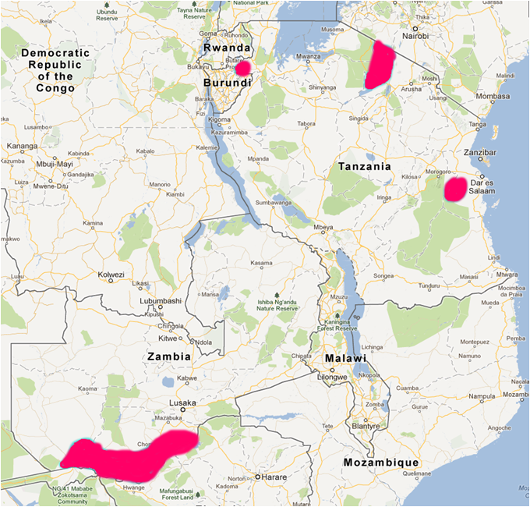

Figure 1 : Area of Pilot Sites

This very successful project has demonstrated the strength and effectiveness of cross-border and inter-sectoral collaboration and the necessity to scale up such interventions for improved disease surveillance.

Empowered by the conclusions of its Pilot Project, SACIDS is now developing a larger-scale project that aims at moving from piloting the use mobile phone technologies for surveillance to the actual establishment of digital national systems for disease surveillance.

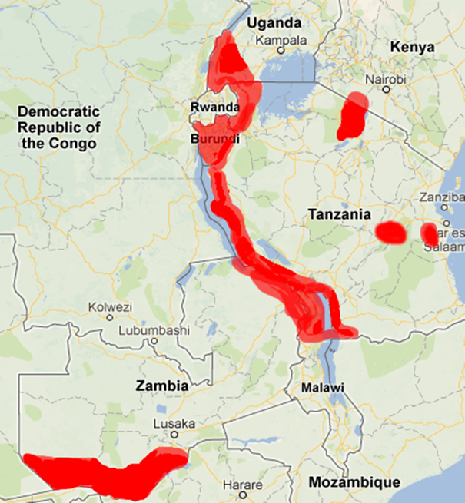

Figure 2 : Proposed Scale-up

Project Goal, objectives and activities :

The goal of this project is to improve the ability to detect and respond to disease outbreaks & epidemics using cross-border collaborations and innovative digital technologies.

This goal will be achieved through the utilization of cross border collaborations and the digital & mobile technologies. The project objectives include improving :

- Disease detection through effective and timely reporting via mobile/digital tools ;
- Disease response by integrating detection signals/data with existing public health prevention and response capacity ;
- Technical capacity, knowledge sharing, and cross border collaboration through the establishment of an ICT Resource Center and engagement by regional surveillance networks.

The project is intimately linked with the existing national surveillance systems and not a stand-alone initiative. Full support was received from the Ministries of Health and the Ministries of Livestock and Fisheries Development. The project will indeed allow the expansion and enhancement of the countries’ traditional surveillance systems operating at the health facility level. To improve the timeliness and quality of routine and passive reporting, it is planed to upgrade these typically paper-based systems to a digital mechanism that includes a network of 800 facilities spanning 6 countries in Eastern and Southern Africa.

Beside the improvement of the traditional health facilities-based surveillance system, the project will expand and enhance the community-based disease detection that was set up by SACIDS in the frame of the Rockefeller Pilot project. The community-based active surveillance system will be based on the recruitment of community health reporters (CHR) in targeted communities. The CHRs will actively search for, register and report (using mobile phones) disease syndromes through submitting data on number of patients, signs and symptoms of selected syndroms (hemorrhagic, respiratory, cutaneous and gastro-intestinal), sex and age of affected animals and humans in their areas/communities.

The set up of a Resource Centre (RC) will be a key component of the project. This RC will serve as a regional hub for technological development and will provide appropriate solutions to support infectious disease surveillance and response in southern and East Africa. The centre will be established at one of NIMR (Tanzania National Institute for Medical Research) duty stations in Morogoro and will consist of three units namely: i) ICT unit (dedicated for designing and programming existing and new applications); ii) Epidemiology Unit (overall overseeing that technologies developed are relevant to infectious disease surveillance as well as coordinating field-testing of the technologies and provision of technical support on geo-spatial and data analysis) and iii) Techonology Transfer unit (responsible for coordinating training and transfer of fit-for-purose technologies developed by the RC in project countries).

Internetwork collaboration :

This project serves well the core essence of CORDS which is to promote collaboration between the networks, global exchanges of best practices, surveillance tools & strategies and innovations.

SACIDS and EAIDSNet will work hand in hand for the implementation of this cross-border project that involves 3 countries from EAIDSNet (Burundi, Kenya and Uganda) and 2 from SACIDS (Tanzania and Zambia). Both networks will be responsible for the project management at the regional level.

MBDS, the Mekong Basin Disease Surveillance Network (MBDS) is the project partner network because of its intense experience these past 6 years in the field mobile technologies for cross-border collaboration and regional data warehouse. MBDS will be involved through project documents review, participation in the project meetings, knowledge sharing, exchange of tools and internetwork learning visits. Moreover, InSTEDD iLab in Cambodia will serve as a model for the set up of SACIDS Resource Center (RC) and the two institutions will collaborate and exchange their expertise.

- Surveillance and mapping of Leishmaniasis cases, vectors and reservoirs to develop a risk index to prioritise interventions – MECIDS and SEEHN (SECID)

Project Executive Summary:

Leishmaniasis –both cutaneous and visceral- is a major public health concern in the Middle-East and in the South eastern Europe countries. In order to improve the surveillance and response to the disease, two networks, MECIDS and SECID have decided to join their efforts and to :

- Create a One Health Virtual Group on Leishmaniasis, a platform for information exchange among experts ;
- Implement a data collection project that aims at establishing a risk index to estimate risk of human exposure to Leishmaniasis.

Project Background :

The Leishmaniases are a group of vector borne diseases caused by various species of the parasitic protozoan Leishmania (Kinetoplastida: Trypanosomatidae) and transmitted by several species of phlebotomine sand flies (Diptera: Psychodidae). The most common clinical forms are cutaneous leishmaniasis, which causes skin sores and the life threatening visceral leishmaniasis, which affects internal organs. More than 20 species of Leishmania parasites, vectored by about 30 species of phlebotomine sand flies, cause infection in people. Particular sand flies spread particular species of the parasite. Leishmaniases can be found in all continents except Australia and Antarctica in a variety of ecological environments ranging from rain forests to deserts and from rural to urban settings. In many areas sand flies and wild and domestic hosts, maintain a zoonotic transmission cycle, while in some regions the transmission cycle is anthroponotic (CDC 2013, WHO 2013).

According to the WHO, until recently, the public health impact of leishmaniasis was underestimated. Disease reporting is required in only 32 of the 88 affected countries and a considerable number of cases are not recorded. An estimated 2 million new cases (1.5 million cases of cutaneous leishmaniasis and 500,000 of visceral leishmaniasis) occur annually, with about 12 million people currently infected. In the last years, the endemic regions of the disease have been spreading and there has been a sharp increase in the number of cases. The phenomenon is attributed to environmental changes and increased land use, such as urbanization, new irrigation schemes, building of dams, deforestation, and the accompanying migration of non-immune people to endemic areas. Climate and other environmental changes have the potential to further expand the geographic range of the disease and increase its burden. Currently no vaccine for the disease or prophylactic drugs to prevent infection is available. Medical treatments are not always obtainable, may have side effects, some require hospitalization and are costly and not always effective. Potential areas of intervention target the vector or animal reservoir populations or attempt to prevent human being bitten by infected sand flies.

Leishmaniasis in the Middle East and Southern Europe: Endemic transmission of leishmaniasis in the Middle East region occurs in developed and urban areas with modern western houses as well as in remote rural villages. Zoonotic transmissions of three different Leishmania species co-exist in the region. Each parasite species is transmitted by different sand fly vector species and resides in different reservoir animals. L. infantum is the causative agent of human and canine visceral leishmaniasis in the region. It is an important cause of morbidity in infants in the Palestinian Authority, and in young adults co-infected with HIV. The vectors in Jordan, the Palestinian Authority and Israel have not been determined.

Cutaneous Leishmaniasis is present both in SECID and MECIDS countries whereas Visceral Leishmaniasis is detected in SECID countries and in small scale in MECIDS countries. In both networks, the number of cases is growing of leishmaniasis and under reporting of cases is common. Various changes have been identified e.g new reservoirs in Palestine and north of Jordan (hyrax) and leishmaniasis, considered as a povery-related disease is now also hitting wealthy areas.

There is a common understanding between the two networks that efforts should be deployed to improve the surveillance and control of leishmaniasis. Moreover, many recent publications recommend the following actions steps:

- To establish a network of experts on Leishmaniasis from various sectors;
- To build a regional system for Leishmaniasis surveillance, kowledge sharing, multisector collaboration and international cooperation.

Project Goal, objectives and activities :

In order to answer to these recommendations and with the goal to strenghten the control of leishmaniasis, CORDS, MECIDS and SECID have joined their effort to establish the “One Health Virtual Group on Leishmaniasis”. The objective of the virtual group is to provide a platform for Leishmaniasis experts from various sectors and countries of the Mediterranean region to share knowledge, data and increase capacities and awareness on Leishmaniasis. The Virtual Group has four major objectives :

- Establish a platform for leishmaniasis experts from different sectors and countries ;
- Establish an innovative way for knowledge sharing, capacity building and problem solving ;
- Improve awareness and funding on Leishmaniasis and further project development ;
- Use knowledge discovery process to establish a data base for gathering of published and unpublished data.

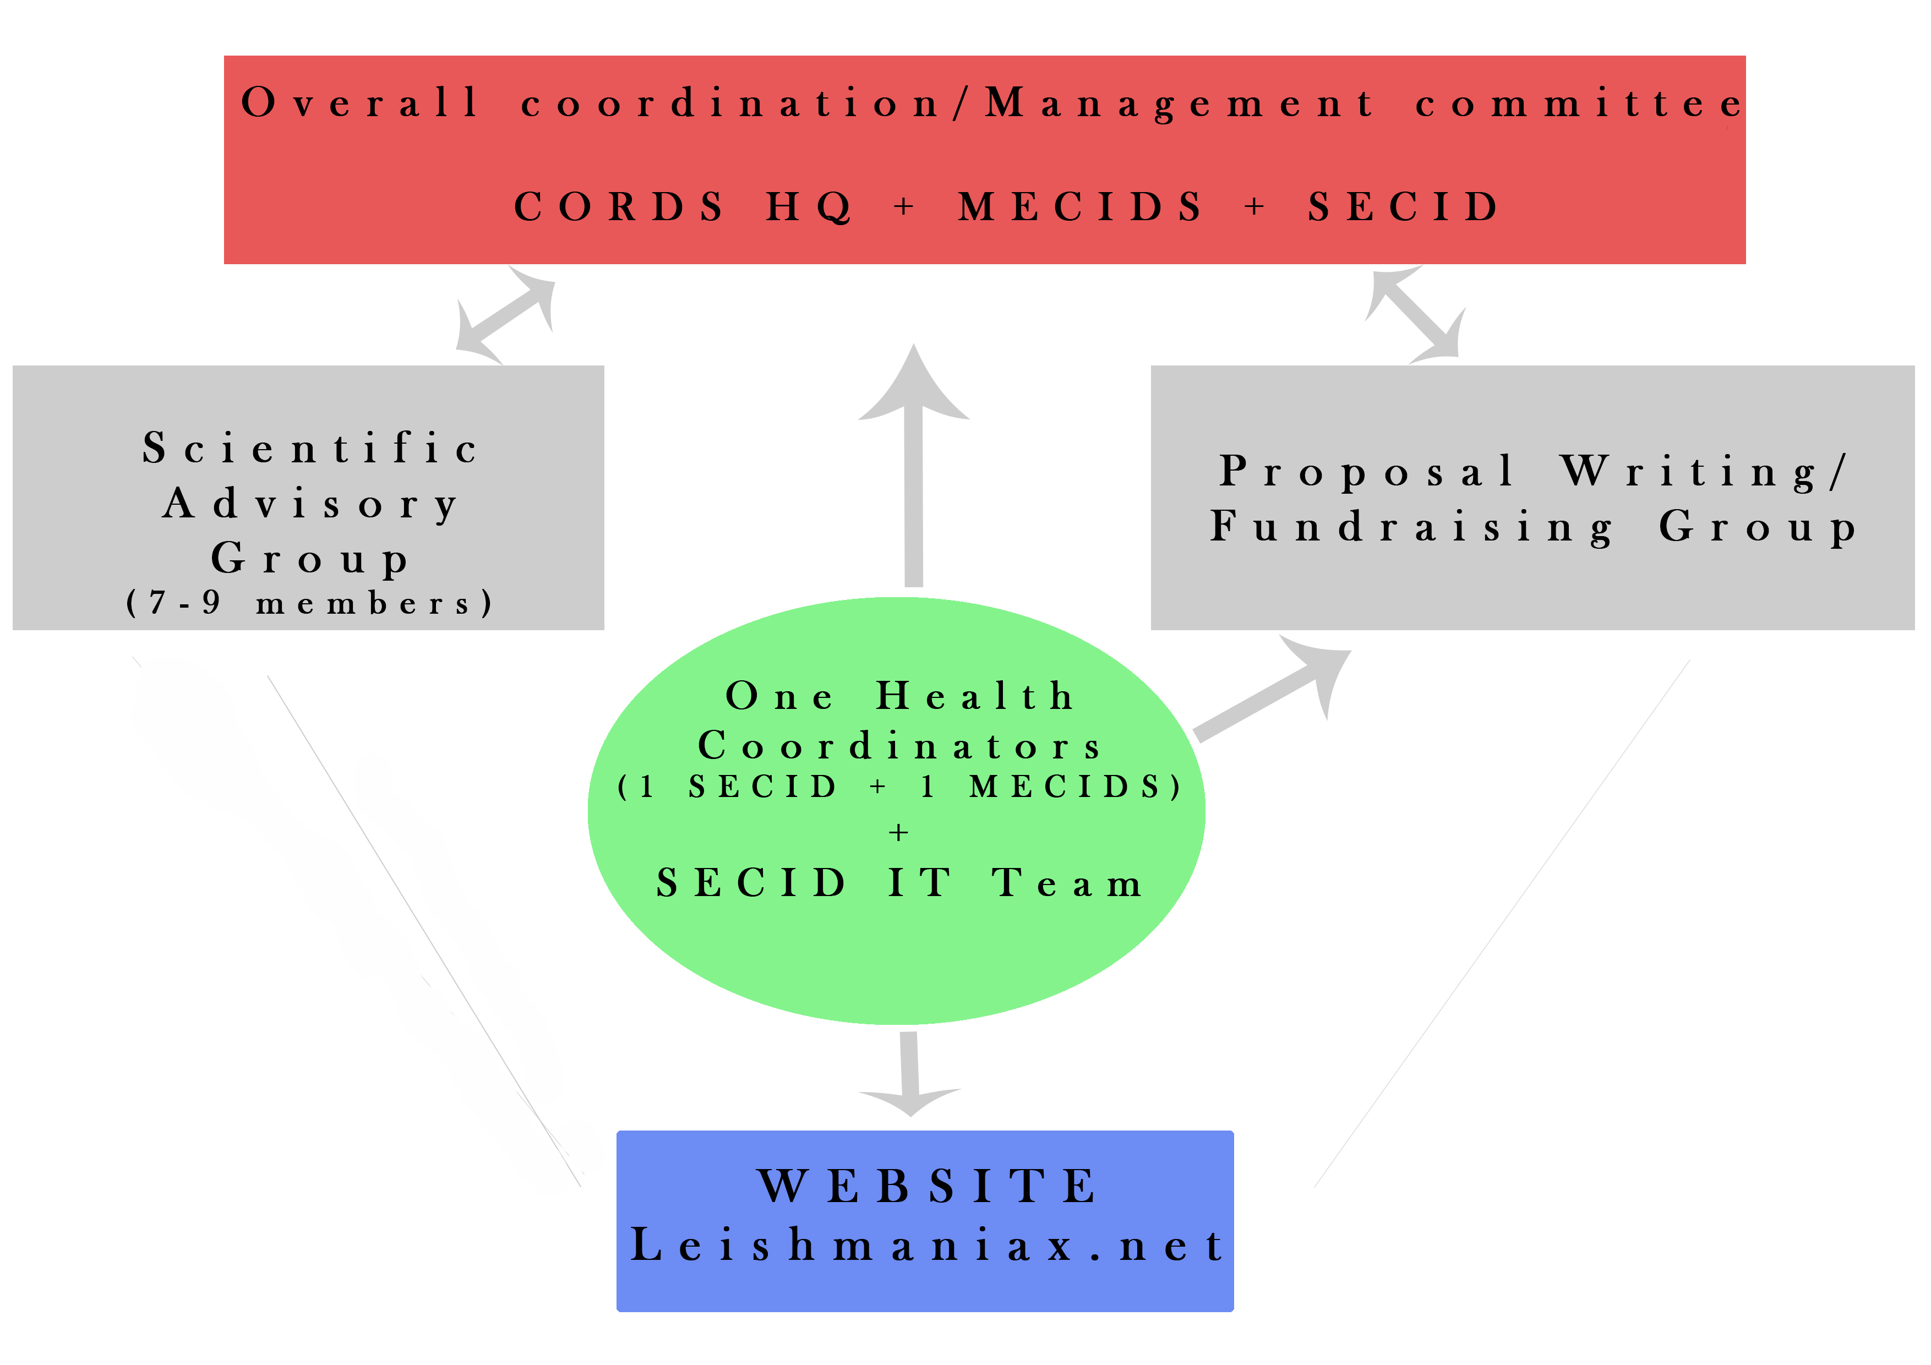

Figure 3 : Virtual Group structure

The website called Leishmaniax will be the main component of the virtual group and be constituted of both a public and a private area. The registered users will be divided into groups according to areas (research, diganosis, entomology, control methods, public health, clinical issues, mapping and epidemiology). The website will be monitored by SECID IT Team and a coordinator recruited in one of the two networks. From this platform, it will be possible to access CORDS, MECDIS and SECID website. The information contained on the Leishmaniax website will be included in CORDS website ; some under the public area, others in the private one.

The Virtual Group will also be the platform for projects development and fundraising of operational research in the networks. The priority of the Group will be to find source of funding for an internetwork project currently being developed by MECIDS and SECID. The focus of the proposal if the establishment of a modulatory stable long-term surveillance platform to collect data that can be used to develop a practical index to estimate risk of human exposure to leishmaniasis. This index can contribute to determine trigger points or threshold for initiating public health and control actions and to evaluate intervention activities outcomes. Surveillance will be conducted in selected areas representing all three-transmission cycles of leishmaniasis in the region. Field information on vector and reservoir populations, Leishmania infection rates in vectors and reservoir, vector-human contacts and morbidity, will be collected simultaneously according to a pre planed monitoring scheme. Periodic analys of the data will enable to assess the minimal monitoring efforts needed and the contribution of each paramenter to the formulation of a reliable risk index.

Setting a regional common goal to reduce leishmaniasis, planning and coordinating a surveillance scheme, exchange of technologies and knowledge, technical asssitance, shared database and joint analysis of the data will help to improve public health and contribute to communication and peace processes. The simultaneous activities in developing and developed areas in urhan and rural environments affected by the three Leishmania transmission cycles, have the potential to generate products relevant to the control of leishmaniasis in other regions of the world.

Internetwork collaboration :

As Leishmaniasis is a public health threat in both SECID and MECIDS regions, these two networks have decided to unite their strength and together establish the One Virtual Group on Leishmaniasis. If some of the major set up activities of the Group will be conducted by SECID
(SECID IT team will develop the website and the group coordinator will be hired by SECID), the contributions to the Platform will come from organizations, researchers and Ministries from both networks.

The research project aiming at developing a risk index for targeted Leishmaniasis interventions will be coordinated by MECIDS but SECID will be in charge of conducting the data collection in the region.

Good internetwork collaboration has been established at CORDS First Annual Conference in April 2013 and then reinforced thanks to the first project meeting in November 2013 in Albania. Moreover, both networks have started to join their main laboratory through informal collaboration between MECIDS and SECID entomologists. A visit from SECID entomologist to MECIDS laboratory in Israël will strenghten this knowledge sharing and capacity building process.

- Mapping maternal and child morbidity and mortality surveillance data in the East African Community Countries to develop a risk index to inform policy on interventions – EAIDSNet

Project Executive Summary:

The East African Community (EAC) Countries have shown limited results in achieving the Millenium Development Goals 4 and 5 (reduce child mortality and improve maternal health) although many initiatives are implemented throughout the various countries of the region. At the present time, there are only very limited number of tools that allow to determine the priority areas for intervention in the field of maternal and child health. As resource prioritization is crucial, it seemed important to develop a new tool to guide policy makers and programmers in prioritizing resources and interventions. The East African Integrated Disease Network of the EAC (EAIDSNet), the East, Central and Southern African Health Community (ECSA) and the Open Health Initiative (OHI) are proposing a project that aims at developing a risk index to enable the such prioritization.

Project Background :

Reproductive, maternal, child and newborn health remain a priority globally and within Partner States of the East African Community (EAC) region. The increasing number of global and regional initiatives arising from different stakeholders to tackle this problem evidences this. These initiatives include the UN Secretary General’s Strategy on women and child health, the Maputo Plan of Action, the Action Plan for the International Conference on Reproductive Maternal Neonatal and Child Health (RMNCH) held in August 2013 in Johannesburg South Africa etc. and more specifically at the EAC level, the Open Health Initiative (OHI).

The above initiatives are cognizant of the insufficient progress of the region to meet the targets of United Nations Millenium Development Goals (MDG) 4 and 5 respectively reduce child mortality and improve maternal health.

Maternal mortality
Barely less than two years to the 2015 MDG target date, overall progress in reducing Maternal Mortality Rate remains slow in the EAC region. With the exception of the Republic of Rwanda, which recorded an overall decline of 63% in maternal mortality between 1990 and 2010, the other countries are unlikely to achieve MDG 5a (reduce by three quarters the maternal mortality ratio). The pace of decline is particularly slow in the Republics of Burundi and Kenya, but quite promising in the Republic of Uganda and the United Republic of Tanzania, which have cut their 1990 MMR levels by almost half.

Neonatal mortality
The rate of reduction in Neonatal Mortality Rates (NMR) in the region between 1990 and 2000 has been off the MDG target mark, raising a lot of concerns. However, the situation in three countries (Republics of Rwanda, Republic of Uganda and United Republic of Tanzania) has improved significantly in 2000s where the highest reduction was registered in Rwanda with 38.5% and 18.1% in Republic of Uganda. Republic of Kenya was the only country in the region that registered an increase (9.2%) in neonatal mortality rates. This increase is a big concern to policy makers and implementers in the region. In order to improve the progress registered in most EAC Partner States and achieve the MDG 4, the EAC countries need to reduce their mortality rates at a faster rate.

Infant mortality
Globally the risk of a child dying before completing the first year of age is highest in the WHO African region (68 per 1000 live births), about six times higher than that in the WHO European region (11 per 1000 live births) (WHO, Global health Observatory). Therefore, infant mortality still remains a major challenge and threat to most infants in East Africa and other parts of Sub Saharan Africa region. The Infant Mortality Rate (IMR) data in the EAC region shows that the region’s performance between 1990 and 2000 has been off the MDG target mark, with an increase in Infant Mortality Rate (IMR). However, the situation improved in 2000s where the levels decreased from 99.1 to 54. Republic of Kenya had the least IMR during the baseline years (60) while Republic of Uganda had the highest (101.2). The IMR figures for the latest year show that Republics of Rwanda and Kenya had the lowest (around 50) while United Republic of Tanzania had the highest (81). Republic of Republic of Uganda had the highest overall decline in IMR while United Republic of Tanzania had the least decline in IMR. The overall trends at country level show that if Republic of Uganda continue with this trend, it is likely to get close to achieving its MDG target by 2015. However, the IMR trends in Tanzania show a lot of concern where the decrease is very marginal compared to other EAC countries.

Under-five mortality
Under-five mortality (U5M), a Millennium Development Goal indicator, is a major indicator of child health and overall development (WHO, Health Status Statistics, 2011). This indicator measures child survival and the levels reflect the social, economic and environmental conditions in which children (and others in society) live, including their health care. Overall, under-5 mortality has decreased throughout the world, from 90 per 1,000 live births in 1990 to 65 in 2008 (WHO, World Health statistics, 2012). There has been a decrease in U5MR levels in the EAC Region. At country level the latest findings show that United Republic of Tanzania has the lowest level (51), followed by Republics of Kenya and Rwanda with U5MR levels of 74 and 76 respectively. Republics of Uganda and Burundi have the highest U5MR rates in the region with 96 and 90 respectively. During the 1990’s, the U5MR levels were as low as 89 in Republic of Kenya and as high as 180.4 in Republic of Uganda. The U5MR rates decreased in all the countries with the highest decrease registered in Republic of Burundi (13.5%) and the lowest decrease were registered Republic of Kenya (3.4).

Studies have been able to determine the major direct and indirect causes of child and maternal mortality. Pneumonia/Respiratory Tract Infections, Malaria, Diarrhea, Malnutrition, Neonatal conditions in particular prematurity and asphyxia have been singled out as the major direct causes of child mortality. On the other hand post partum hemorrhage, abortion; sepsis, obstructed labor, Pregnancy associated hypertension; HIV and Malaria have been singled out as the major causes of maternal deaths in Sub-Saharan Africa.

The above findings have been informative in prioritizing interventions for health programmes in Sub-Saharan Africa. They have led to clinical packages of interventions like Integrated Management of Childhood Illnesses, which seeks to address all the major causes of child deaths at a one-stop treatment point. On the other hand Emergency Obstetric Care has been devised to provide a package of clinical interventions, which address the major causes of maternal deaths.

Despite the above progress, there are minimal programmatic tools geared towards determining regions or populations, which should be addressed first with such intervention packages. In an era where resources are limited and resource prioritization is gaining more momentum, it is important to search out for new tools that are able to guide policy makers and programmers in prioritizing resources and interventions.

This project seeks to contribute to the available efforts of developing tools, which are able to measure the geographical, or population risk to maternal morbidity or mortality, and child morbidity and mortality.

Project Goal, objectives and activities :

The goal of the project is to reduce maternal and child mortality and morbidity in the East African Community (EAC).

The project purpose is to develop a risk index to enable the prioritization of resources and interventions for the reduction of maternal and child mortality and morbidity in the EAC Partner States.

Five objectives have been defined :
1. Investigate the prevalence and incidence of maternal and child health mortality and morbidity in the EAC at regional, national and sub national level;
- Assess the causes and risk factors of maternal and child mortality and morbidity in the EAC;
- Map the epidemiological data down to the district level;
- Develop the Risk Index;
- Facilitate the adoptation of the Risk Index in the policy and planing frameworks of the EAC

The project is proposed jointly by the East African Community (EAC) through the East African Infectious Disease Surveillance Network (EAIDSNet), the Open Health Initiative (OHI) and by the East, Central and Southern African Health Community (ECSA-HC) through the World Bank funded East African Public Health Laboratory Networking Project (EAPHLNP). An agreement between these two organizations is already in place.

It is envisioned to identify gaps, strengths and synergies between the various initiatives conducted by these stakeholders in the field of Maternal and Child Health. Thus, one essential synergy component will be the use of data from the OHI and the EAPHLNP to develop and feed into the Risk Index.

Stakeholders | Contribution
EAC-EAIDSNet | - Statistics Department  - Data Warehouse  - Data protection rules  - Monitoring & Evaluation Unit
EAC-Open Health Initiative | - Data  - Data warehouse management  - Budget for data collection
ECSA-EAPLNP | - Laboratory/centres of excellence data (diseases causing maternal and child deaths)
APEIR & MBDS | - Peer review of the project documents  - Experience sharing in the development of Risk Index
Figure 4: Table summarizing the contribution of each stakeholder to the project

A regional advisory pannel including the five Integrated Disease Surveillance and Response (IDSR) Heads of each EAC partner states will be constituted and structured around the rules of the EAC (for the chairmanship for example). In addition to the five IDSR Heads, five technical persons (maternal and child health specialists) shall be included.

Internetwork collaboration :

Two other CORDS networks from the South East Asia region, the Asian Partnership on Emerging Infectious Diseases Research (APEIR) and the Mekong Basin Disease Surveillance Network (MBDS) will contribute to the project through peer review of project documents and sharing of experience in Risk Index development.

This project will also liaise with two other CORDS networks, respectively the South Eastern Europe Health Network (SEEHN) and the Middle East Consortium on Infectious Diseases Surveillance (MECIDS) specifically on the development of the Risk Index as these two networks are also envisioning the modeling of such tools as part of their project on Leishmaniasis as an examplar of Vector borne disease Surveillance.

InSTEDD’s iLabs support the shared exploration of solutions to health, safety and sustainable development problems. The iLabs act as enabling environments for technology transfer and collaboration between software developers, governments, NGOs, universities, private sector companies, local communities and experts from a variety of disciplines

