CONNECTING ORGANIZATIONS FOR REGIONAL DISEASE SURVEILLANCE
THE FIRST FIFTEEN MONTHS
January 1, 2013 to March 31, 2014

The CORDS mission is to connect regional disease surveillance networks to improve global capacity to respond to infectious disease threats.

Overview

CORDS is extremely grateful to its donors:

- the Skoll Global Threats Fund grant ($1M) provides the foundations for CORDS operations;
- The Bill and Melinda Gates Foundation grant ($1.5M) is dedicated to innovative operational research projects;
- the Rockefeller Foundation grant ($1M) is designated for capacity building;
- the Nuclear Threat Initiative and Fondation Merieux for invaluable in-kind support.

All grants were received in late 2012. We therefore began our operations in earnest on January 1, 2013. NTI made a special grant to provide strategic support to the Executive Director in pursuing US Government funding.

It has been a very busy time with many successful achievements.

The CORDS Launch

CORDS was launched very successfully on 29 January, 2013 at the Prince Mahidol Awards Conference in Bangkok, Thailand. It was attended by over 100 persons. Keynote presentations from Jeanette Vega (Rockefeller), Larry Brilliant (Skoll Global Threats Fund), Former Senator Sam Nunn (Nuclear Threat Initiative) and Ann Marie Kimball (The Bill & Melinda Gates Foundation) extolled the virtues of CORDS and their organizations’ support for its activities. The CORDS Executive Director presented CORDS’ Strategy and chaired a panel of the CORDS networks members who showcased their work. The launch was recorded.

The Conference included many CORDS presentations. One session in particular was devoted to “Making Networks Work”. A CORDS research brainstorm was held on the final day, 2 February.

The CORDS Strategy
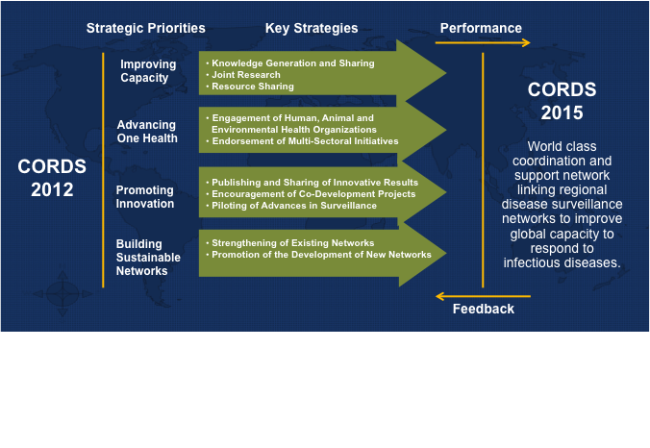

Implementing the CORDS strategy

During 2013, CORDS has implemented its strategy through the following interdependent activities:

- Gathering the Networks together – the Annual Conference
- Mapping the stakeholders and networks in the CORDS regions
- Developing communication
  - Risk communication training
  - Communication policy and strategy
- Developing communication tools
- Planning One Health Workshops
- Initiating innovative operational research projects across networks
  - Mobile phone technologies to improve One Health surveillance in SACIDS, EAIDSNet and MBDS
  - Surveillance of leishmaniasis cases, vectors and reservoirs to develop a risk index in MECIDS and SEEHN
  - Mapping of maternal and child morbidity and mortality in EAIDSNet
- Advocacy
- Identifying partners and future funding

The Annual Networks Conference

The first CORDS’ Annual Networks Conference was held 22, 23 &24 April, 2013 at the Fondation Merieux Conference Centre at Les Pensières, Annecy, France. It was attended by 36 persons and included public health, veterinary, information technology and communications experts.

The intent of the conference was to bring together representatives from all six Networks to build relationships and engagement, but also to enhance understanding and expectations vis-à-vis CORDS and foster the development and empowerment of the CORDS network of trusted networks. The conference sought to refine and develop coordinated local action plans in the realms of One Health and in-network training, communication and knowledge management, and innovative operational research.

One Health was deemed to be a key foundation principle for CORDS. The importance of respecting existing reporting systems was acknowledged and opportunities to foster information dissemination and inter-network collaboration amongst CORDS networks and country members deemed highly desirable. As a first step, the networks collectively endorsed a phased One Health scenario based training regime whereby scenarios would be progressively rolled out to veterinarians, public health practitioners and finally joint sessions carried out. This regime is founded on realistic, regionally relevant, cross-border scenarios, executed first as table top simulations and subsequently as field training exercises. It was agreed that templates would be shared through the CORDS website to the benefit of all Networks. Networks have nominated representatives to work on One Health workshop development.

Functional stakeholder mapping was selected as a CORDS priority initiative. Members agreed that such a mapping would provide greater visibility over a complex disease surveillance environment. This mapping would also be useful for identifying key linkages/stakeholders across the entire surveillance to intelligence continuum (detection, verification, confirmation and analysis).

Following a presentation on risk communication, members agreed that training within this area would be beneficial. From an operational research perspective, two projects have been endorsed by members; namely, Surveillance of Leishmaniasis, and Mobile Phone Technologies for Surveillance. Notional project objectives, activities, considerations and resources have been scoped and Network leads and supporting resources assigned to each of the projects.

It was agreed that a new CORDS website comprised of tools, a public and private area needs to be developed. The proposed website is not intended to replace or reinvent capacity that already exists. It will be redesigned to act as a hub for communication within the CORDS network. Member input was obtained and personnel nominated within each network to provide input and advice on the redesign.

Finally, the member networks provided details of their own action plans for the coming two-year period and identified specific aspects of these for which CORDS could provide support.

Stakeholder mapping

Knowledge of all of the stakeholders operating around the CORDS networks is essential for their further development and their sustainability

Stakeholder mapping has been completed. The maps will be uploaded to the new CORDS website as it is developed over the next four months and be available to all users. The Skoll Global Threats Fund has found the maps very useful to date and intend to commission one for South Asia.

The stakeholder mapping has revealed a plethora of other actors and networks in the regions. It is worthy of a new initiative to facilitate engagement between these players as part of our network developments.

Communication

Communication is the foundation stone of building trust and stimulating earlier communication between countries and between networks. The activities of risk communication training, the development of the CORDS website and portal and the implementation of a CORDS communication policy and strategy feed into each other.

a) Risk Communication

CORDS held a very successful Risk Communication Training Workshop at Rockefeller’s Bellagio Training Center, Italy, on 8-12 July 2013. Fifteen delegates from the networks attended. The workshop was designed, developed and delivered by dickmann risk communication drc|. The conference received additional support through a special grant from the Rockefeller Foundation Bellagio Center.

A pre-course assessment and an initial survey questionnaire were sent to all participants. Their responses, including descriptions of their recent outbreak-related experiences revealed an interest and need for further development of their risk communication skills and capacities.

The course emphasized active learning and was mainly organized around a series of interactive group exercises focused on a variety of communicable disease- related scenarios. The scenarios looked at three keys aspects of risk communication- information sharing, communication, and coordination. The discussion topics included:
- Information: Lessons learned from H5N1 translated into H7N9 in China
- Communication: Ebola outbreak in the Democratic Republic of the Congo
- Coordination 1: Cholera
- Coordination 2: Yellow fever
- Coordination 3: Dengue
- Exercise: MERS Coronavirus (in regional network groups)

Participants were asked to develop Ministerial briefings and action plans. This interactive working was described as “highly valuable and enjoyable” by the participants. The group work consistently scored highly in the end of day assessments.

Participants described the workshop atmosphere as being “stimulating and at times ‘electrically’ filled with enthusiasm.” Many new connections between networks were reported and a resolution was agreed to “take this teaching back into our networks.” The geographically related networks agreed to work together on their future risk communication enterprises.

A further locally based workshop for the SACIDS network was held in Dar es Salaam. The power of these locally based events to bring together the major actors in emerging infections responses should not be underestimated. One of the recommendations from the networks following the Bellagio Risk Communication event was to develop a CORDS handbook. This remains in our plans and we are seeking funding.

The participants identified a need for improved communication between countries and between networks. They requested that a portal, with a secure password protected area, be developed to facilitate earlier, faster and better communication between them. The participants identified varying levels of sensitivity to early release of information between countries. Networks have agreed that their boards should appoint a focal point for information sharing. Participants voiced the opinion that “trust will be built and strengthened through collaborative working and the development of “CORDS Rules” for sharing.”

b) Internal Communication Policy and Strategy

The CORDS policy and strategy for internal communication has been developed in consultation with the networks and was presented to the November Board meeting. After taking into account the Boards members’ views it has been finalized and is being distributed.
It has been recognized that in order to further develop communication, people are required to work together, and that “gathering” is important, but expensive for a global network. Therefore the website and tools being developed will provide opportunities for meetings in a video conference space. We are actively seeking further funding for in person “gatherings.”.

c) Platform and Portal

CORDS completed the first stage of this project in early 2013, conducting a needs assessment that was completed at the Annecy Conference, discussed above. The networks themselves already have their own websites and what is really needed is an information and news website with a library area for published documents and protocols and a password protected area to facilitate early event information exchange, i.e. in the early period of uncertainty and to facilitate document development between networks. The networks will be involved in the further development of the functions and specifications of the website.

The website planning continued in 2013, taking into account the output of the risk communication training and the communication policy and strategy. One of the important factors has been the networks’ IT specialists input and this initially slowed down progress. However we have now formed them into a group to assist in the website development. It is important that they feel that they own it and therefore contribute to its content and use it.

Contractors have been commissioned for the development of the website and for the initial content. The key innovations in the website will be a password protected members area and a tool for setting up video/audio conferences easily using the internet. The password protected area will facilitate discussions during the early period of uncertainty at the beginning of any event. It will also facilitate ongoing document development in a confidential space. Completed documents and protocols will be published on the public area of the website. We are seeking further funding for ongoing maintenance and further development that will include a real-time daily news service. The intention is to create a website owned by the networks and for the networks to encourage use by all members on a constant basis.

Innovative Operational Research Projects

The Bill & Melinda Gates funding is dedicated to innovative operational research projects and is utilized for “seed corn funding” to get major network projects planned and proposals written to seek additional funding; they are big projects:

a) Mobile phone technologies for surveillance - SACIDS, EAIDSNet and MBDS

This project builds on the successful Rockefeller Foundation funded pilot study carried out by SACIDS. Based on the achievements of the 2009 DSN 305 project the proposed project will cover a wider geographical area in Southern and East Africa. It is proposed to scale up the One Health disease surveillance activities from the four pilot zones (Ngorongoro, Kagera river basin and Zambezi river basin to other zones (Figure 1b), that will include:

- The whole of Burundi country
- The whole zone along the Western Rift Valley from Malawi to Uganda. The zone will include Northern provinces of Malawi, Eastern and North Provinces in Zambia as well as part of Mbeya, Rukwa, Kigoma and Kagera regions in Tanzania. In Uganda, all districts within the Western Rift Valley (Albertine Rift) i.e. the stretch between Arua district (in the north) and Kabale&Ntungamo districts (in the south) will be covered.
- Extension from Ngorongoro (Tanzania) to Southern Kenya (Narok and Kajiado districts)
- Extension from Kibaha to Kilosa district in Morogoro region of Tanzania.

The project area is inhabited by approximately 21 Million human population and it covers a belt of about 1,940 kilometre (1,205 miles) extending from the north western Uganda ( Arua district) to the Northern Province of Malawi.

The first project meeting took place in San Francisco following the Digital Disease Detection Conference (DDD) in September 2013 at Skoll Global Threats Headquarters. Among others, representatives from SACIDS and MBDS were present as long as a team from InSTEDD (http://instedd.org), the project technical partner. A side meeting was also organized with a reduced audience to discuss thoroughly the technical details of the project.

This is not another pilot project but a real scale up of capacity using android phones at community level to report not only routine surveillance data but also event-based information to district and national level.
The project goal is to improve the ability to detect and respond to disease outbreaks & epidemics using cross-border collaborations and innovative digital technologies. Three main objectives have been identified : (1) improve disease detection, (2) improve public and animal health response and (3) increase collaboration and technical capacity.

The project will revolve around a Resource Centre (RC). This RC will serve as a regional hub for technological development and will provide appropriate solutions to support infectious disease surveillance and response in southern and East Africa. The centre will be established at one of NIMR (Tanzania National Institute for Medical Research) duty stations in Morogoro and will consist of three units namely: i) ICT unit (dedicated for designing and programming existing and new applications); ii) Epidemiology Unit (overall overseeing that technologies developed are relevant to infectious disease surveillance as well as coordinating field-testing of the technologies and provision of technical support on geo-spatial and data analysis) and iii) Techonology Transfer unit (responsible for coordinating training and transfer of fit-for-purose technologies developed by the RC in project countries).
During a visit to Tanzania in February 2014 from CORDS Executive Director and Programme Manager, the project has been briefed to the Chief Medical Officer and his staff at the Ministry of Health and Social Welfare (MoHSW) and the Chief Veterinary Officer and his staff at the Ministry of Agriculture and Fisheries Development who have given their full support. The project is not meant to be a stand alone initiative but is envisioned to fill gaps in existing national surveillance systems and sit alongside the Ministries’ eHealth and mHealth projects (eIDSR and digital pen technology among others).

At the date of this report being prepared, the project proposal is being finalized by a consortium composed of SACIDS, CORDS HQ and InSTEDD. It is envisioned to submit an official Grant Application to Skoll Global Threats by mid-April.

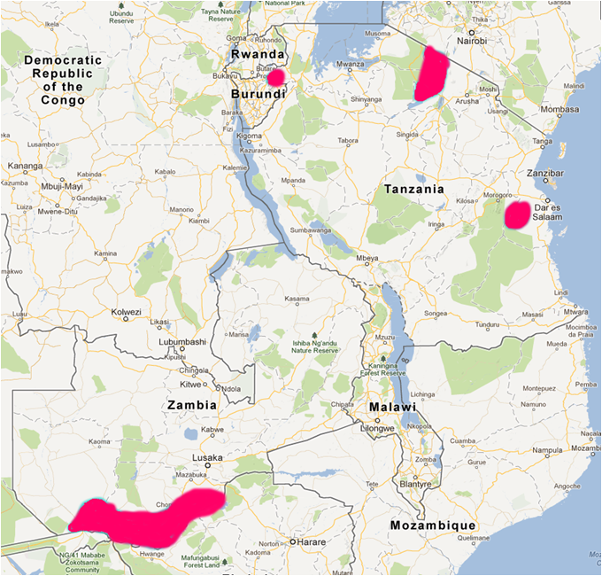 |  | 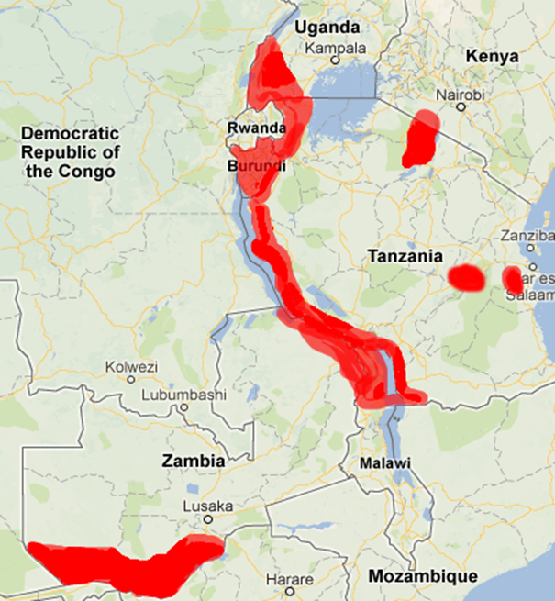
Fig 1a: Pilot sites (DSN 305 Project) |  | Fig 1b: Proposed scaling up geographically

b) Surveillance and mapping of leishmaniasis cases, vectors and reservoirs to develop a risk index to prioritise interventions MECIDS and SEEHN

Cutaneous Leishmaniasis is prevalent in certain parts of MECIDS with foci in certain locations, new foci are occurring and the challenge is to be able to predict where the next foci may occur in order to make effective interventions.

Visceral Leishmaniasis is prevalent in Albania and is associated with feral dogs. It is present in some of the surrounding countries but is absent in others.

Leishmaniasis is dependent on the reservoir and on the vectors (various species of sand flies). The aim of the project is to collect and analyse the surveillance data on human cases, the vectors and the reservoirs. This will then be mapped together with other layers of information to develop a risk index to inform policy decisions on effective interventions. A project proposal and roadmap have been prepared and discussed during the first project meeting in Tirana in November 2013. The meeting gathered the Southeast European Center for Surveillance and Control of Infectious Diseases (SECID) team and one representative from each MECIDS country. During this workshop, the project development team agreed to create a “One Health Virtual Group on Leishmaniasis” which objective is to provide a platform for Leishmaniasis experts from various sectors and countries of the Mediterranean region to share knowledge, data and increase capacities and awareness on Leishmaniasis.

Some of the Gates funding will likely be allocated to the set up of the Virtual Group while additional Grant funding is being pursued for the data collection and risk Index development

c) Mapping maternal and child morbidity and mortality surveillance data in the East African Community countries to develop a risk index to inform policy on interventions – EAIDSNet

This project is proposed jointly by the East African Community through the East African Infectious Disease Surveillance Network (EAIDSNet), the Open Health Initiative (OHI) and by the East, Central and Southern African Health Community (ECSA-HC) through the World Bank funded East African Public Health Laboratory Networking Project (EAPHLNP). An agreement between these two organizations is already in place. It is envisioned to identify gaps, strengths and synergies between the various initiatives conducted by these stakeholders in the field of Maternal and Child Health. Thus, one essential synergy component will be the use of data from the OHI and the EAPHLNP to develop and feed into the Risk Index. The development of such tool would enable the prioritization of resources and interventions for the reduction of maternal and child mortality and morbidity in the EAC Partner States.

Two other CORDS networks from the South East Asia region, the Asian Partnership on Emerging Infectious Diseases Research (APEIR) and the Mekong Basin Disease Surveillance Network (MBDS) will contribute to the project through peer review of project documents and sharing of experience in Risk Index development.

This project will also liaise with two other CORDS networks, respectively the South Eastern Europe Health Network (SEEHN) and the Middle East Consortium on Infectious Diseases Surveillance (MECIDS) specifically on the development of the Risk Index, as these two networks are also envisioning the modelling of such tools as part of their project on Leishmaniasis as an examplar of Vector borne disease surveillance.

One Health Workshops

The One Health concept is an important principle of the CORDS strategy. Our implementation strategy is to hold One Health workshops at regional level and include policy decision makers. A One Health workshop has been held in 2013 in SEEHN (Zagreb 14-15 June) involving all countries veterinary and health surveillance agencies. The purpose of the meeting was to “ assess the risks and public health importance of zoonosis in SEE countries, address challenges and build upon success stories to establish a One Heath Approach for effective zoonotic diseases surveillance, control and prevention”. The aim is to develop a training module based on the outcomes of the SEEHN initiative with input from OIE and FAO. One workshop is currently being planned.

Multi-sectoral activities

CORDS has joined with Interpol to deliver a series of biosecurity workshops that are being held in the CORDS networks’ regions. The International Federation of Biosafety Associations (IFBA) is also helping. The workshops are being funded by the Canadian and United States Governments, there is no cost to CORDS apart from the time commitment of the Executive Director. The first workshop was held in Amman, Jordan and attended by Jordan, Iraq and the Lebanon. CORDS was requested to look at the feasibility of forming a new network of these countries and a proposal has been submitted to the US State Department Biological Engagement Program for funding over two years. The second workshop has just been held in Vietnam where MBDS and APEIR were closely involved. The next workshops will be held in Georgia and Tanzania.

OIE is now a member of CORDS and monthly meetings are held in Paris. OIE is assisting CORDS with the development of the One Health training module.

The Executive Director met with FAO in March and parallel objectives were identified. A Memorandum of Understanding (MoU) is being drafted to identify the areas in which we will work closely together. The following issues have been identified: (1) Risk Communication, training and earlier communication, (2) Network mapping, (3) Network Development, (4) Intelligence Gathering, (5) Reaching Down to Community Level, (6) Mobile Phones for Surveillance and (7) Specific Disease Surveillance (Leishmaniasis – mapping and learning from Trypanosomiasis eradication and Burcellosis in East Africa).

Advocacy

The CORDS mission and activities have been briefed to a wide spectrum of influential potential funders:

- The Executive Director has continued to work closely with the networks and has visited all of them. He has also engaged with governments to gain political support for the networks and with the G8 Global Partnership and with Interpol. He has been successful in obtaining funding from the Canadian Government for the development of APEIR and MBDS jointly; two of the CORDS networks in Southeast Asia that previously tended to work separately.
- The Executive Director has presented CORDS at The White House to US Government Department officials and funding is being pursued with the Defence Threat Reduction Agency (DTRA) to continue the CORDS mission. The verbal feedback from these meetings was that funding CORDS is a “no brainer.” A formal proposal to submit to the appropriate channels is being worked on.
- The Executive Director attended meetings at the US State Department. He attended the Biological Engagement Program stakeholders’ meeting and has submitted a proposal to form a new network in Iraq, Lebanon and Jordan.
- Following a presentation by the Executive Director at the June 2013 Global Partnership Biological Sub Working Group, CORDS is now a member of the G8 Global Partnership and is pursuing funding from the GP members.
- The Executive Director has met with Dame Shirley Williams and discussions were held on the feasibility of developing a new network to include Iran.
- The Executive Director has met with Princess Haya of Jordan who is a wife of the UAE Prime Minister. A meeting with him and senior health officials is being pursued to look at the feasibility of a Gulf States CORDS network.
- The Executive Director has also met with the UK Ministry of Defence, The Health Threats Unit of DG SANCO at the European Commission and has attended the German national exercise on biological threats.
- The Executive Director is a Senior Fellow at Chatham House and leads a project on Global Health Security that publicizes CORDS and influences policy. He chairs a group of senior officials from the United States, Canada, United Kingdom, Germany, Denmark, Finland, India, Uganda, Viet Nam, China, Indonesia and The Philippines. He is developing a new measurement tool to measure capacity for global health security and has submitted a proposal the the US State Department Biological Engagement Program.
- CORDS has become a member of a group of US based NGOs who have agreed to work together to help the implementation of The Global Health Security Agenda.
- An application for ECDC funding to improve public health preparedness in EU expansion countries some of which are our network countries was unsuccessful. The reasons given were that CORDS does not have an established reputation or a management structure for delivery in this field.

Identification of funding

Successes
Canadian Government, DFAID, Network strengthening for biosecurity – 450K CAD to APEIR, 450K CAD to MBDS and 100K CAD to CORDS HQ

Proposals submitted
US Government, State Department BEP, Establishing a new network in Iraq, Lebanon and Jordan - $1,773,860 in three phases over two years.

Proposals in preparation
a) US Government, DTRA, CORDS strengthening, operations, communication, annual conferences - $3M over three years;
b) Rockefeller Foundation, Strengthen CORDS networks, harness achievements and resources and diversify to improve sustainability - $1M over one year to eighteen months;
c) Skoll Global Threats Fund, CORDS development and operating costs - $1M;
d) Skoll Global Threats Fund, Funding for Mobile phone technologies project.

CORDS has funding until the end of 2014, it is urgent that new funding sources are identified now. The Executive Director is actively seeking new grants. A CORDS Board Funding subcommittee has been established to identify sources of future funding.

CORDS Headquarters
The CORDS Headquarters is nimble and agile and has three permanent staff; the Executive Director, Executive Assistant, and Program Manager.

A consultant Finance Director (Charlotte Atkinson, formerly of NTI) oversees our budget, grants management and advises on CORDS’ general financial situation. She is reliant on book-keeping and preparation of the annual accounts which was provided by French accounting firm, Orial, until December, 2013 and, from January 2014, is provided by KPMG.

A consultant communication/strategy manager will be contracted when funds are available.

Risks

a) CORDS reputation has been enhanced greatly through the efforts of the Executive Director.

b) WHO is an observer at the Board, and remains to be convinced of the value of CORDS; we are often seen as competition and they have mistakenly assumed that we collect surveillance data instead of it being sent to WHO. At many high profile meetings I have stressed that our work improves reporting to them. We are building capacity for early surveillance that is reported by the countries in our networks through the normal channels to the international organizations who have the global responsibility. This has been validated by OIE becoming a member of CORDS and the imminent MOU with FAO. A high level meeting is being sought with WHO to further address and resolve this misunderstanding.

c) Funding remains our biggest challenge. Avenues are being pursued.

