New learnings and experiences during my summer internship with CORDS
Lindsay Steele

It’s a Friday evening in early July in Dar es Salaam, Tanzania and I’m sitting at the rooftop restaurant of the Holiday Inn, in awe of my surroundings. There’s a young man tending the BBQ, cloaked in smoke from skewered meats.

A group of twenty-somethings, dressed in what appears to be their finest hijabs, are out for the evening. A few fellow hotel guests are enjoying the local cuisine. Based on their dress and lack of enthusiasm, I assume they frequent Tanzania for business. Local pop music videos are projected onto a large screen, with the speakers turned up high.

Sitting a few hundred meters from the Indian Ocean, I reflect on my past weeks and months, feeling thankful for the series of new experiences and learnings, that started with my arrival to Lyon, France for a summer internship with Connecting Organizations for Regional Disease Surveillance (CORDS).

CORDS is made up of six Regional Disease Surveillance Networks, who in turn are made up of a consortia of countries that work to advance the capabilities for early infectious disease detection, control, and response between its member countries.

Choosing CORDS for my internship

I first learned about CORDS when I worked for partner and funding organization, Skoll Global Threats Fund. I got to know CORDS well during this time. In fact, during those few years, CORDS was established, Professor Nigel Lightfoot CBE, was appointed as Executive Director, and the hard work began towards a world united against infectious diseases.

With the passion and interests I developed while working with Skoll, I left my position there to pursue graduate school – a Masters of Science in Public Health at McGill University. My program includes a summer internship, to gain work experience in the field and use my newly developed skills and knowledge.

Doing my internship at CORDS was a no-brainer. It fit my interests, I knew the organization well (so the transition would be easy for everyone), and I knew the top-notch team and projects would yield a rewarding learning experience.

I arrived in Lyon in May (where CORDS HQ is currently based). After getting my bearings, I travelled with the CORDS team to Tirana, Albania for the Annual CORDS Networks Conference.

Developing a measurement framework for earlier disease detection

The week was a whirlwind of learning and relationship building. It furthered my development of a measurement framework for earlier disease detection – a tool I was working on to enable CORDS and comprising Networks to measure whether or not diseases are being detected earlier, and to identify drivers for change.

Using the Conference to collect information and feedback from stakeholders, I returned to Lyon energized.

With the information in hand, I needed to dive deeper to understand the complex details of the current disease detection situations in Network countries, along with the desired situations that would enable earlier detection. I used CORDS risk management workshops as opportunities to collect this data that would form the evidence-base for the measurement framework for four CORDS Disease Surveillance Networks: EAIDSNet, MECIDS, SACIDS and SECID.

First stop: Budva, Montenegro

I was here to work with and learn from IHR Focal Points in MECIDS and SECID countries. In small working groups, participants dissected disease detection activities and identified necessary conditions and influencing factors for earlier disease detection.

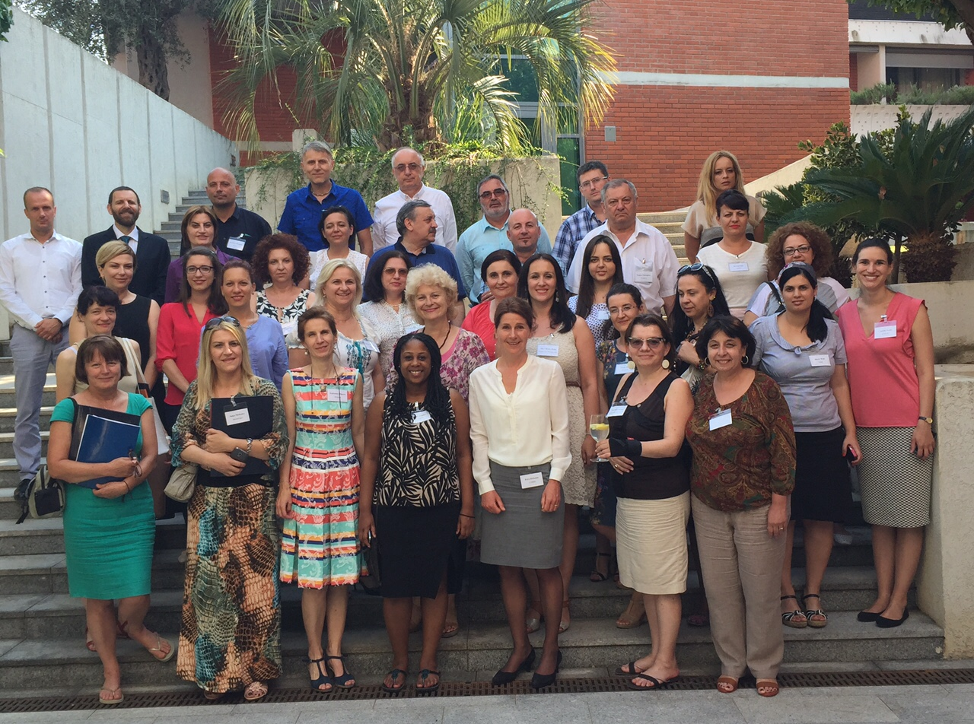

SECID-MECIDS participants, Risk Management
Workshop July 6-7, 2015

Second stop: Dar es Salaam, Tanzania

We repeated the exercise here with experts in EAIDSNet and SACIDS countries. The second workshop came to a close on that Friday evening, when I retreated to the rooftop restaurant above the Indian Ocean.
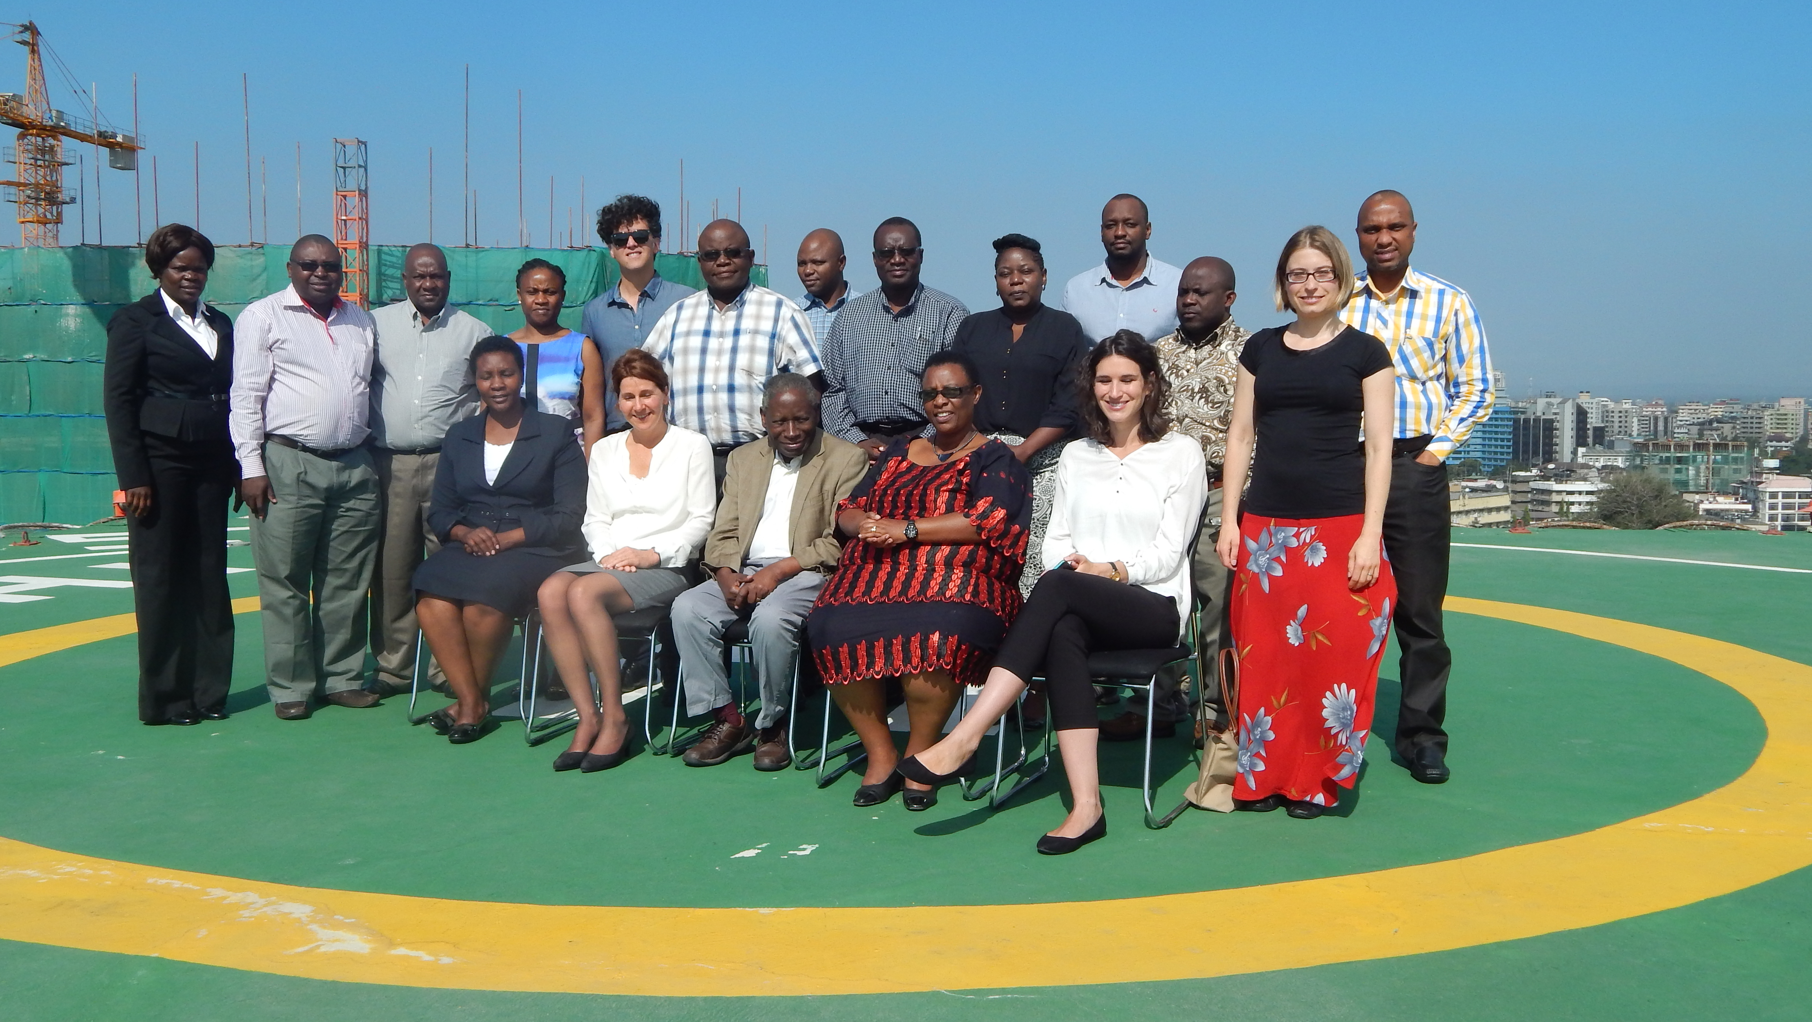

EAIDSNet-SACIDS participants, Risk Management
Workshop July 9-10, 2015

Back on that rooftop, my body is exhausted but my mind is brimming with ideas. These two-day intensive workshops in Budva and Dar es Salaam produced sets of empirical data on necessary conditions and factors that influence earlier detection in the respective regions. Armed with this new set of information, I have clarity on how the measurement framework will come together, and a plan for the final seven weeks of my internship.

I arrive back to Lyon, and work closely with my colleagues at CORDS to complete the analysis of the data and finalize the structure for the measurement framework.

Back home in Montreal

Now I’m back home in Montreal, Canada, where I will finish the final year of my Masters program and will continue working with CORDS to develop indicators for the framework.

I am grateful for my experience this summer – I feel good about the work that I produced, I made new colleagues and friends, and developed my skills as a researcher.

Many colleagues have already contributed to the work by sharing their knowledge, expertise and stories. I will be in touch with existing and new collaborators from the Networks, and would like to extend my sincere gratitude to all of the intellectual partners that have and will work with me and CORDS on this!

