1. “Surveillance and Response to Avian and pandemic Influenza by National Health Authorities of South East Europe” Project
ILI/ARI/SARI Meeting in Montenegro
On 19 February 2015 in Montengro was held the ILI/ARI/SARI Meeting.
This activity has been organized in the framework of the second year implementation of the Project “Surveillance and Response to Avian and pandemic Influenza by National Health Authorities of Countries of South East Europe”.
The meeting started with presentation on the influenza surveillance system in Montenegro; afterwards the meeting followed with three other presentations: a) on MERS-CoV; b) on Avian influenza A(H7N9) virus; c) on Surveillance of ILI/ARI/SARI (epidemiology, virology); Hospital SARI surveillance of severe acute respiratory infection (SARI).

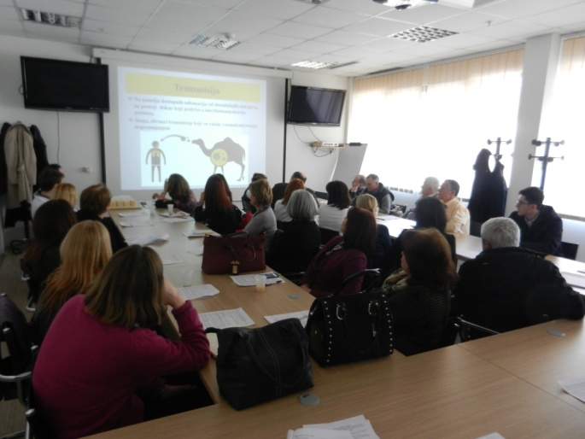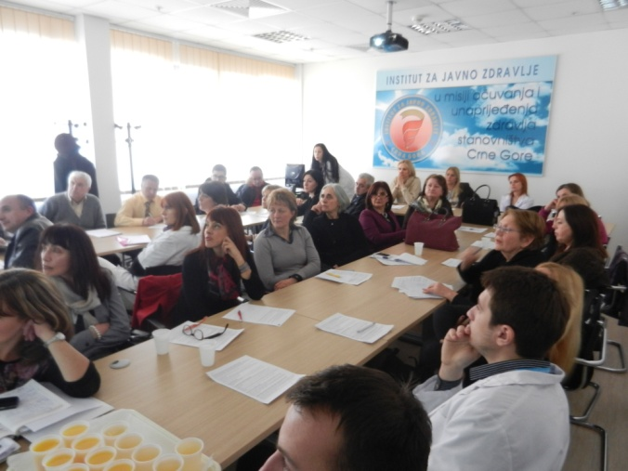

2. One Health Workshops
SECID has completed all the preparing work (documentation; logistics etc) for the One Health Workshop on Zoonoses that will take place in Prizren, Kosovo*, on 12&13 March 2015. This is the first one of three cross border One Health Workshops to be organized in SEE region within May 2015. In this context we are finalizing the second OH, that will be held in Bulgaria. For this reason Dr Angel Kunchev from Bulgaria is invited in OH of 12-13 March, Prizren in order to observe and modify their One Health workshop according to their needs. The third cross-border OH with the participation of Serbia, Montengro and Bosnia & Herzegovina is still at the first steps of organization.
3. Conference calls
SECID has participated in conference and skype calls with CORDS representatives regarding the development of project proposal on Leishmaniasis.
In the framework of CORDS ‘Network mapping’ activity, on 26th February 2015 SECID representatives ( Ms Ledia Agolli and Dr. Silvia Bino) have been contacted and interviewed by Ms. Emma Orefuwa, Programme Manager of CORDS.
4. Meeting on Screening and Prevention of Cervical Cancer in Albania
This meeting took place in Tirana, Albania on 03 February 2014 in the framework of the European week for prevention of cervical cancer, in collaboration with IPH and Albanian Center for Population and Development (ACPD) and supported by UNFPA
It was a consultative meeting among experts (health professionals from MOH, IPH, University of Tirana, Maternities etc.), aiming to promote and support the screening and prevention of cervical cancer for all women in Albania. The participants made an analysis of present situation and discussed about WHO guideline and how to adapt it in Albania. In conclusion, the participants agree about the further steps to be followed regarding the screening and prevention of cervical cancer.

